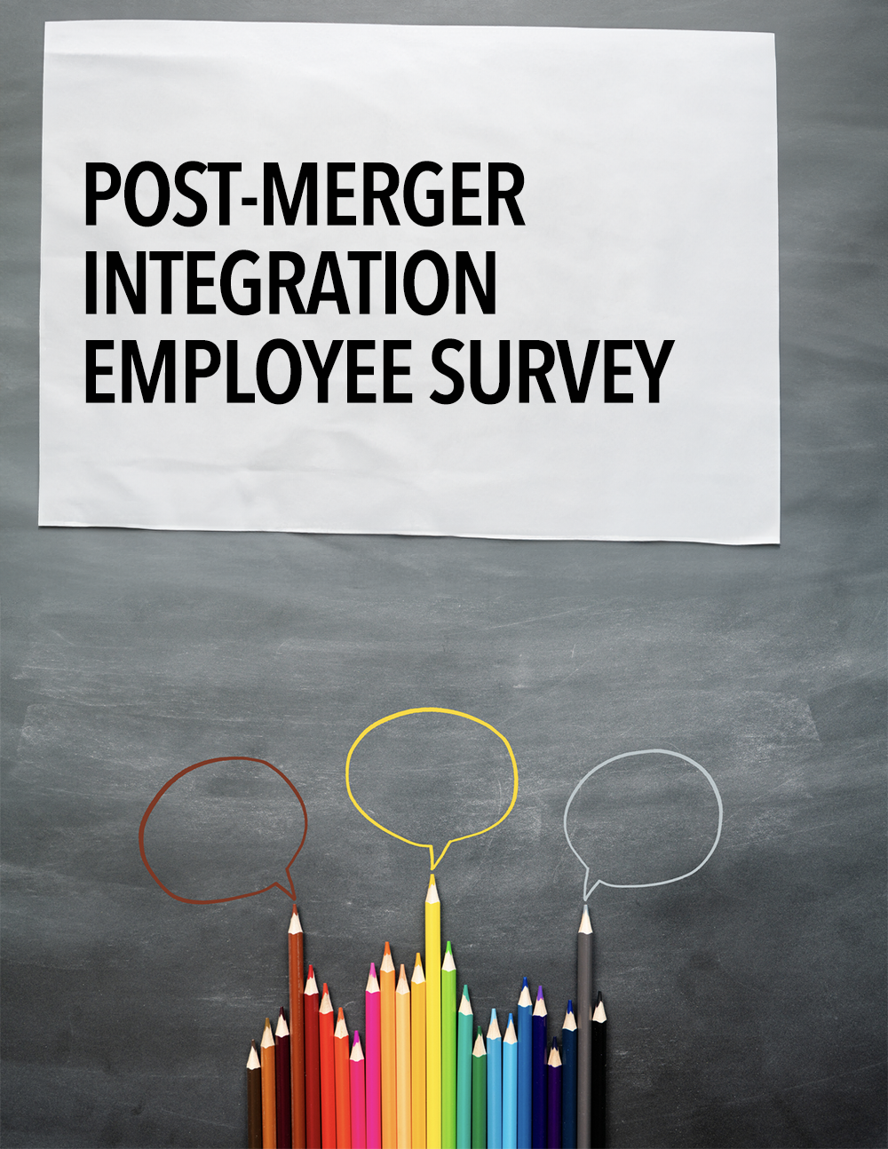
POST-MERGER INTEGRATION SURVEY

Previous Company: ____________
Location: _____________________

Instructions: Please answer the following questions using a rating scale of 1-5, circling the one number on the scale you feel best describes your opinion. Feel free to add comments whenever you think it will add clarity or details regarding your response. The results of this survey will be used to brief senior management regarding integration progress and priorities for the future.

- I am confident that by joining forces our companies will be able to deliver greater value to our customers.

1 2 3 4 5
Agree Agree Undecided Disagree Disagree
Completely Somewhat Somewhat Completely

Comments: ________________________________________________________________________________________________________________________________________________________________________________________________________________________________________________________________________________________________________________________________________________________________________________________________________________________________________________

- I believe our customers are confident in our ability to deliver greater value to them as a result of our companies joining forces.

1 2 3 4 5
Agree Agree Undecided Disagree Disagree
Completely Somewhat Somewhat Completely

Comments: ____________________________________________________________________________________________________________________________________________________________________________________________________________________________________________________________________________________________________________________________________________________________________________________________________________________________________________`___

- I understand how our companies joining forces can benefit me in the future.

1 2 3 4 5
Agree Agree Undecided Disagree Disagree
Completely Somewhat Somewhat Completely

Comments: ________________________________________________________________________________________________________________________________________________________________________________________________________________________________________________________________________________________________________________________________________________________________________________________________________________________________________________

- Through their actions, our senior leadership team has demonstrated their commitment to making the transition period as fast and smooth as possible.

1 2 3 4 5
Agree Agree Undecided Disagree Disagree
Completely Somewhat Somewhat Completely

Comments: ________________________________________________________________________________________________________________________________________________________________________________________________________________________________________________________________________________________________________________________________________________________________________________________________________________________________________________

- Our executive leadership team is effectively retaining the mission critical strengths of the two companies as we combine forces.

1 2 3 4 5
Agree Agree Undecided Disagree Disagree
Completely Somewhat Somewhat Completely

Comments: _______________________________________________________________________________________________________________________________________________________________________________________________________________________________________________________________________________________________________________________________________________________________________________________________________________________________________________
- The vision of NewCo is clear to me.

1 2 3 4 5
Agree Agree Undecided Disagree Disagree
Completely Somewhat Somewhat Completely

Comments: ________________________________________________________________________________________________________________________________________________________________________________________________________________________________________________________________________________________________________________________________________________________________________________________________________________________________________________

- The values of NewCo are clear to me.

1 2 3 4 5
Agree Agree Undecided Disagree Disagree
Completely Somewhat Somewhat Completely

Comments: ________________________________________________________________________________________________________________________________________________________________________________________________________________________________________________________________________________________________________________________________________________________________________________________________________________________________________________

- The cultural traits that NewCo will recognize and reward are clear to me.

1 2 3 4 5
Agree Agree Undecided Disagree Disagree
Completely Somewhat Somewhat Completely

Comments: ________________________________________________________________________________________________________________________________________________________________________________________________________________________________________________________________________________________________________________________________________________________________________________________________________________________________________________

- The business processes for working together are clear to me.

1 2 3 4 5
Agree Agree Undecided Disagree Disagree
Completely Somewhat Somewhat Completely

Comments: ________________________________________________________________________________________________________________________________________________________________________________________________________________________________________________________________________________________________________________________________________________________________________________________________________________________________________________

- I am receiving timely information related to the integration process.

1 2 3 4 5
Agree Agree Undecided Disagree Disagree
Completely Somewhat Somewhat Completely

Comments: ________________________________________________________________________________________________________________________________________________________________________________________________________________________________________________________________________________________________________________________________________________________________________________________________________________________________________________

- The communication I’m receiving related to the integration process is adequate.

1 2 3 4 5
Agree Agree Undecided Disagree Disagree
Completely Somewhat Somewhat Completely

Comments: ________________________________________________________________________________________________________________________________________________________________________________________________________________________________________________________________________________________________________________________________________________________________________________________________________________________________________________

- I understand how our products and services will fit together in the future.

1 2 3 4 5
Agree Agree Undecided Disagree Disagree
Completely Somewhat Somewhat Completely

Comments: ________________________________________________________________________________________________________________________________________________________________________________________________________________________________________________________________________________________________________________________________________________________________________________________________________________________________________________

- I have enough information to effectively communicate with customers, vendors, and suppliers about our new combined portfolio of products and services.

1 2 3 4 5
Agree Agree Undecided Disagree Disagree
Completely Somewhat Somewhat Completely

Comments: ________________________________________________________________________________________________________________________________________________________________________________________________________________________________________________________________________________________________________________________________________________________________________________________________________________________________________________

- I understand how the new organization will be organized.

1 2 3 4 5
Agree Agree Undecided Disagree Disagree
Completely Somewhat Somewhat Completely

Comments: ________________________________________________________________________________________________________________________________________________________________________________________________________________________________________________________________________________________________________________________________________________________________________________________________________________________________________________

- I understand where and how I fit into the new organization.

1 2 3 4 5
Agree Agree Undecided Disagree Disagree
Completely Somewhat Somewhat Completely

Comments: ________________________________________________________________________________________________________________________________________________________________________________________________________________________________________________________________________________________________________________________________________________________________________________________________________________________________________________

- I have confidence in the leadership of the combined organization.

1 2 3 4 5
Agree Agree Undecided Disagree Disagree
Completely Somewhat Somewhat Completely

Comments: ________________________________________________________________________________________________________________________________________________________________________________________________________________________________________________________________________________________________________________________________________________________________________________________________________________________________________________

- I have access to the necessary resources (information, materials, equipment) to do my job effectively.

1 2 3 4 5
Agree Agree Undecided Disagree Disagree
Completely Somewhat Somewhat Completely

Comments: ________________________________________________________________________________________________________________________________________________________________________________________________________________________________________________________________________________________________________________________________________________________________________________________________________________________________________________

- Decisions affecting my work are being made in a timely and effective manner.

1 2 3 4 5
Agree Agree Undecided Disagree Disagree
Completely Somewhat Somewhat Completely

Comments: ________________________________________________________________________________________________________________________________________________________________________________________________________________________________________________________________________________________________________________________________________________________________________________________________________________________________________________

- My priorities to meet my deliverables in the next 30 days are clearly defined.

1 2 3 4 5
Agree Agree Undecided Disagree Disagree
Completely Somewhat Somewhat Completely

Comments: ________________________________________________________________________________________________________________________________________________________________________________________________________________________________________________________________________________________________________________________________________________________________________________________________________________________________________________

- For the next 30 days, I can meet my deliverables to achieve our ordinary and ongoing business objectives.

1 2 3 4 5
Agree Agree Undecided Disagree Disagree
Completely Somewhat Somewhat Completely

Comments: ________________________________________________________________________________________________________________________________________________________________________________________________________________________________________________________________________________________________________________________________________________________________________________________________________________________________________________

- Teams are collaborating to coordinate efforts across the two organizations to maximize the success of the transition to one combined company.

1 2 3 4 5
Agree Agree Undecided Disagree Disagree
Completely Somewhat Somewhat Completely

Comments: ________________________________________________________________________________________________________________________________________________________________________________________________________________________________________________________________________________________________________________________________________________________________________________________________________________________________________________

- I am excited about working for NewCo.

1 2 3 4 5
Agree Agree Undecided Disagree Disagree
Completely Somewhat Somewhat Completely

Comments: ________________________________________________________________________________________________________________________________________________________________________________________________________________________________________________________________________________________________________________________________________________________________________________________________________________________________________________

- I expect good career opportunities for me in NewCo.

1 2 3 4 5
Agree Agree Undecided Disagree Disagree
Completely Somewhat Somewhat Completely

Comments: _______________________________________________________________________________________________________________________________________________________________________________________________________________________________________________________________________________________________________________________________________________________________________________________________________________________________________________

- I expect to be working for NewCo 12 months from now.

1 2 3 4 5
Agree Agree Undecided Disagree Disagree
Completely Somewhat Somewhat Completely

Comments: ________________________________________________________________________________________________________________________________________________________________________________________________________________________________________________________________________________________________________________________________________________________________________________________________________________________________________________

- Overall, the process of joining forces is going well.

1 2 3 4 5
Agree Agree Undecided Disagree Disagree
Completely Somewhat Somewhat Completely

Comments: ________________________________________________________________________________________________________________________________________________________________________________________________________________________________________________________________________________________________________________________________________________________________________________________________________________________________________________

A Chance to Be Heard

- One thing I would like the senior management of NewCo to know is:

27. One thing that would help me to do my job better in the next 90 days is:

28. One thing we’ve done extremely well in integrating the two companies is:

29. One thing we could have done better in integrating the two companies is:

30. One thing I’m still uncertain about is:

